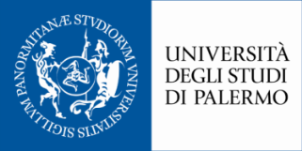
Department of Psychology, Education Sciences
And Human Movement

Application form
14th “Migrants, Human Rights, Democracy” Summer School
(Palermo 8-12 June 2020)

PERSONAL DETAILS
Title (Mr/Miss/Mrs/Ms/Dr): …….
Family/last name: …………………………………………………………………………………
First name(s): ………………………………………………………………………………………
Country: …………………………………………………..
Date of birth: DD/MM/YYYY
Email address: …………………………………..
Nationality (as per your passport): ………………

ACADEMIC AND PROFESSIONAL DETAILS
Please give details of your educational background, including current study and degrees achieved:
[_] Studying for Bachelor’s Degree
[_] Bachelor’s Degree
[_] Studying for Master’s Degree
[_] Master’s Degree
[_] Studying for PhD
[_] PhD
[_] Other
[_]Organization/Affiliation (if any) ……
Please give details of your status: Student | Employed | Retired | Academic | Other - Profession: ……

ATTACHEMENTS
Please attach to your application:
- Copy of a valid identity document (I.D. card – Passport);
- Short CV

Date __________ Signature ___________________________

Please email your fully completed application form in PDF/scanned version to:

Director of the Summer School, Prof. Elisabetta Di Giovanni
Università degli Studi di Palermo, summermigrantiunipa@gmail.com
no later than 31 March 2020.

